

North & Middle Pill Residents and Business Survey and Questionnaire
Number 2
Report of Findings – May 2014

First and foremost, sincere thanks are given to all those Residents and Businesses who have given their time to contribute to this important piece of work. We hope you find the results of interest.

Following on from its four Pre-Application Advice submissions to Cornwall Council during the winter of 2013/14, the Landowner Consortium distributed its second survey questionnaire to the Resident and Businesses of North and Middle Pill in April 2014. The purpose was to gain the community’s preferences in respect of five important questions :-

- Their preference for the nature and composition of the development;
- Their preference for the scale of development in terms of overall housing numbers;
- Their preference on where development should take place within the area;
- Their preference for the appropriate level of green and environmental investment; and
- Their priorities for Local Investment and Improvement.

Survey questionnaire No. 2 can be viewed at www.tamarvillagesaltash.co.uk under the “Documents” tab.

The findings will have a direct bearing on how the development brief and proposals for this community-building development are derived and shaped.

Data Protection Act 1998
Responses provided have been treated as confidential information. Data has been analysed and aggregated to prepare The Report of Findings from the individual responses received.

The Tamar Village Saltash Landowner Consortium
Phil & Delia Greenwood; Ian & Tracy Broad; Liz Payne (Trustee W Holman Trust); Bill & Elaine Holman

Please do visit www.tamarvillagesaltash.co.uk for a wealth of information about the scheme.

Response Rate

A total of 44 questionnaires were delivered to Residents and Businesses in N&M Pill.
8 returns were received from residents and 3 were received from businesses.
Two letters were also received.

The first letter was from the nine beneficiaries of the W. Holman Trust, eight of whom grew up in North and Middle Pill. They indicated that they were now assuming greater responsibility for the future of Tamar Park farm. They expressed unequivocal support for “a development of exceptional quality of which past generations of their family would be proud.”

The second was from Helen Hocking, the Chair of the North and Middle Pill Neighbourhood Association, a group formed to oppose development. 21 residents and 2 businesses from that group chose not to contribute to the survey questionnaire (no.2) as their preference is for “no development.”

“Any change, even for the better, is always accompanied by drawbacks and discomforts.”
Arnold Bennett (1867-1931) English Novelist.

Method of Analysis

Responders were asked to rank their preferences to each Option provided for each of the five questions. The rankings for each option from each responder were added together. The resulting totals for each option were then in turn ranked from highest preference to lowest preference. This methodology was undertaken for both residents and business responses. The results from these two groups were aggregated to provide a combined ranking.

The Findings

Question 1. What is your preference for the Nature of Development ?

 | 1. All Affordable | 2. Mixed Low Density w/ Live Work & Hub (Tamar Village concept) | 3. Option 2 with Reduced Affordable | 4. High quality Low Density Estate Style | 5. Option 4 with Reduced Affordable
Residents : Ranking | 5 | 3 | 1 | 4 | 2
Businesses : Ranking | 5 | 1 | 3 | 2 | 4
Combined : Ranking | 5 | 2 | 1 | 4 | 3

Whilst both residential and business responders expressed a preference for the Tamar Village concept over a conventional estate development, preferences were split on the level of affordable housing to be included. The combined preference scores indicated a preference for a reduced level of affordable housing. A development entirely of affordable housing was the least favoured option by both resident and business responders.

Question 2. What is your preference for the Scale of Development ? (The number of houses)

 | 1. Up to 50 homes | 2. 50-100 homes | 3. 100-150 homes | 4.150-200 homes | 5.200-250 homes
Residents : Ranking | 4 | 2 | 1 | 3 | 5
Businesses : Ranking | 5 | 4 | 1 | 1 | 3
Combined : Ranking | 5 | 2 | 1 | 2 | 4

Resident and Business responders alike expressed a preference for the 100-150 home scale of development, although the business responders expressed an equal preference for the 150-200 option. Businesses regarded “up to 50 homes” as their least favoured option whilst for residential responders this was a development of 200-250 homes.

Question 3. Where should the development take place in N&M Pill ?
(Refer to the Location Plan provided at the rear of the Report.)

 | 1.  Shutes and Mill Park | 2. Barn Park | 3.  Cockles Farm | 4.  North Park A | 5.  Pill Lane | 6.  Cross Park Lodge | 7.  Salt Mill Creek | 8.  Tamar Park A | 9.  Tamar Park Farmstead | 10.  North Park B
Residents : Ranking | 1 | 2 | 4 | 3 | 5 | 7 | 9 | 10 | 6 | 8
Businesses : Ranking | 3 | 2 | 1 | 3 | 3 | 8 | 9 | 10 | 6 | 6
Combined : Ranking | 2 | 1 | 3 | 4 | 5 | 8 | 9 | 10 | 6 | 7

Preference was expressed by both Residential and Business responders for any development to be concentrated on the western side of the area being:-
- Cluster 1 - Shutes Field and Mill Park;
- Cluster 2 – Barn Park;
- Cluster 3 – Cockles Farm; and
- Cluster 4 – North Park.
The least favoured development clusters expressed by both residential and Business respondents related to the two sites with river frontage and the sites to the north-east and south-east sides of North Park being :-
- Cluster 6 – Cross Park Lodge;
- Cluster 7 – Salt Mill Creek;
- Cluster 8 – Tamar Park; and
- Cluster 10 – North Park B.
The redevelopment of the Tamar Park farmstead, an important issue for the W. Holman Trust attracted neither strong positive or negative preferences from either Residential or Business responders.

Question 4. What do you consider should be the appropriate level of Green and Environmental Investment for the development ?

 | 1. High Green Credentials | 2. Medium Green Credentials | 3. Compliant Green Credentials
Residents : Ranking | 1 | 2 | 3
Businesses : Ranking | 2 | 1 | 3
Combined : Ranking | 1 | 1 | 3

Both Residential and Business Responders indicated a preference for a development which exceeded current Building Regulation and prevailing Environmental Standards for development.

Compliance with existing standards was expressed as the least preferred option by both groups.
Question 5. What are your Local Priorities for Investment ? (The Look)

 | 1. Improve-ments to Cutlers Corner | 2.  Cycle Path from Shutes Cottage to Pill Lane | 3. Vehicle Turning at Tamar Park | 4. Riverside Cycle Path | 5.  Green Travel Measures | 6.  Tree-lined Avenue at Shutes Cottage | 7. Exceptional landscape treatment with Clusters | 8. Public open space | 9. Education, Social Care, Police, Fire, Highway, Ambulance, Leisure, Space Contribution | 10. Community Agriculture, Composting and Social Enterprise Schemes | 11. Superfast Broadband Provision | 12.  Creation of Employment | 13. Provision of Village Hub | 14.  Foul Drainage, Storm Water and Flood Mitigation measures | 15.  Habitat Enrichment
Residents : Ranking | 2 | 1 | 10 | 9 | 14 | 10 | 3 | 13 | 15 | 4 | 8 | 6 | 7 | 12 | 5
Businesses : Ranking | 1 | 7 | 15 | 12 | 10 | 7 | 5 | 11 | 12 | 14 | 5 | 3 | 2 | 4 | 9
Combined : Ranking | 2 | 1 | 14 | 11 | 13 | 10 | 3 | 12 | 15 | 7 | 8 | 4 | 6 | 9 | 5

Residential responders rated their highest preferences for investment as :-
- Highway/traffic improvements at Cutlers Corner to Salt Mill;
- Cyclepath/footpath provision from Salt Mill up to the Pill Lane junction; and
- Exceptional landscape treatment to the development clusters.
Business responders rated their highest preferences as :-
- Highway/traffic improvements at Cutlers Corner to Salt Mill;
- The provision of a Village Hub; and
- The creation of employment.
This question provoked the most divergence of opinion between the two groups, but probably reflects a difference in their quality of life and business aspirations and objectives.
Least interest was shown in :-
- The provision of a turning facility at the Tamar Park end of Pill Lane;
- Green travel measures;
- Public Open Space; and
- Section 106 planning obligation payments to Cornwall Council in relation to education, social care, highway and other public services
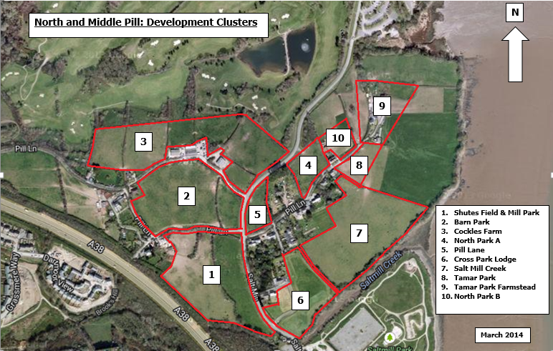

Next Steps

As stated previously the findings from survey questionnaire No.2 will have a direct bearing on how the development brief and proposals for this community building development are derived and shaped

We will continue to seek views and preferences on other facets of the Tamar Village project in the coming weeks and months.

The Tamar Village Saltash Landowner Consortium was formed in 2012 to promote a ground-breaking development at the “Gateway to Cornwall”
Phil & Delia Greenwood; Ian & Tracy Broad; Liz Payne (Trustee- W Holman Trust); William & Elaine Holman
www.tamarvillagesaltash.co.uk

